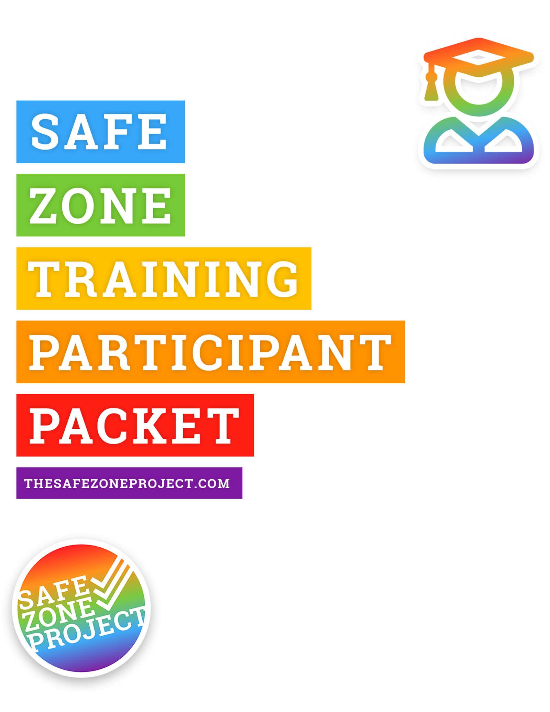e
5.0 Edition

Training Overview

Group Norms
First Impressions of LGBTQ
Core Vocabulary
LGBTQ Umbrella
Genderbread Person
Privilege for Sale
Questions, Questions, Questions
Scenarios
Feedback

Group Norms

1. Be Smarter than Your Phone
No matter how good you are at multitasking, we ask you to put away your phone, resist from texting and all that jazz. We will take a break and you can send a quick text, snap, tweet, insta, etc. at that point. If you are expecting a phone call you cannot miss we will not judge!

2. Questions, Questions, Questions
Please feel free to ask questions at any time throughout this training. Unless someone is mid-sentence, it is always an appropriate time to ask questions. Even if it isn’t relevant to the topic, throw it out there – get it off your mind and on to ours.

3. Vegas Rule
Slightly modified! So during the training someone may share something really personal, may ask a question, may say something that they wouldn’t want attached to their name outside this space. So remember that what is said here stays here and what is learned here leaves here. You’re welcome to share anything that we say in this space with others and attach it to our name but we respectfully request that you take away the message from others’ shares and not their names.

4. LOL
We really appreciate it if, at some point, y’all could laugh! This training is going to be fun, and we’ll do our best to keep it upbeat, so just know… it’s ok to laugh! Laughter indicates that you’re awake, that you’re paying attention, and that we haven’t killed your soul. So yeah… go ahead and do that!

5. Share the Airtime
If you are someone who participates often and is really comfortable talking – awesome! Do it. Also we ask that you try to remain aware of your participation and after you’ve shared a few times to leave space for other people to also put their ideas out there. If you usually wait to share… jump in!

6. Reserve the Right to Change Your Mind
If you say something and then later disagree with yourself, that is a-okay! This is a safe space to say something and then later feel differently and change your mind. We even encourage it. As a wise Safe Zone participant once said, “Stop, rewind, I changed my mind.”

First Impressions of LGBTQ People
Answer the following questions to the best of your ability:
1. When’s the first time you can remember learning that some people are lesbian, gay, bisexual, or queer?

2. Where did most of the influence of your initial impressions/understanding of lesbian, gay, bisexual, and queer people come from? (e.g., family, friends, television, books, news, church)

3. When’s the first time you can remember learning that some people are transgender?

4. Where did most of the influence of your initial impressions/understanding of transgender people come from? (e.g., family, friends, television, books, news, church)

5. How have your impressions/understanding of LGBTQ (lesbian, gay, bisexual, transgender, and queer/questioning) people changed or evolved throughout your life?

Core Vocabulary
ally /“al-lie”/ – noun : a (typically straight and/or cisgender) person who supports and respects members of the LGBTQ community. We consider people to be active allies who take action on in support and respect.
asexual – adj. : experiencing little or no sexual attraction to others and/or a lack of interest in sexual relationships/behavior. Asexuality exists on a continuum from people who experience no sexual attraction or have any desire for sex, to those who experience low levels, or sexual attraction only under specific conditions. Many of these different places on the continuum have their own identity labels (see demisexual). Sometimes abbreviated to “ace.”
biological sex – noun : a medical term used to refer to the chromosomal, hormonal and anatomical characteristics that are used to classify an individual as female or male or intersex. Often referred to as simply “sex,” “physical sex,” “anatomical sex,” or specifically as “sex assigned at birth.”
biphobia – noun : a range of negative attitudes (e.g., fear, anger, intolerance, invisibility, resentment, erasure, or discomfort) that one may have or express toward bisexual individuals. Biphobia can come from and be seen within the LGBTQ community as well as straight society. biphobic – adj. : a word used to describe actions, behaviors, or individuals who demonstrate elements of this range of negative attitudes toward bisexual people.
bisexual – 1 noun & adj. : a person who experiences attraction to some men and women. 2 adj. : a person who experiences attraction to some people of their gender and another gender. Bisexual attraction does not have to be equally split, or indicate a level of interest that is the same across the genders an individual may be attracted to. Often used interchangeably with “pansexual”.
cisgender /“siss-jendur”/ – adj. : a gender description for when someone’s sex assigned at birth and gender identity correspond in the expected way (e.g., someone who was assigned male at birth, and identifies as a man). A simple way to think about it is if a person is not transgender, they are cisgender. The word cisgender can also be shortened to “cis.”
coming out – 1 noun : the process by which one accepts and/or comes to identify one’s own sexuality or gender identity (to “come out” to oneself). 2 verb : the process by which one shares one’s sexuality or gender identity with others.
gay – 1 adj. : experiencing attraction solely (or primarily) to some members of the same gender. Can be used to refer to men who are attracted to other men and women who are attracted to women. 2 adj. : an umbrella term used to refer to the queer community as a whole, or as an individual identity label for anyone who is not straight.
gender expression – noun : the external display of one’s gender, through a combination of clothing, grooming, demeanor, social behavior, and other factors, generally made sense of on scales of masculinity and femininity. Also referred to as “gender presentation.”
gender identity – noun : the internal perception of an one’s gender, and how they label themselves, based on how much they align or don’t align with what they understand their options for gender to be. Often conflated with biological sex, or sex assigned at birth.
genderqueer – 1 adj. : a gender identity label often used by people who do not identify with the binary of man/woman. 2 adj. : an umbrella term for many gender non-conforming or non-binary identities (e.g., agender, bigender, genderfluid).
heteronormativity – noun : the assumption, in individuals and/or in institutions, that everyone is heterosexual and that heterosexuality is superior to all other sexualities. Leads to invisibility and stigmatizing of other sexualities: when learning a woman is married, asking her what her husband’s name is. Heteronormativity also leads us to assume that only masculine men and feminine women are straight.
homophobia – noun : an umbrella term for a range of negative attitudes (e.g., fear, anger, intolerance, resentment, erasure, or discomfort) that one may have toward LGBTQ people. The term can also connote a fear, disgust, or dislike of being perceived as LGBTQ. homophobic – adj. : a word used to describe actions, behaviors, or individuals who demonstrate elements of this range of negative attitudes toward LGBTQ people.
homosexual – adj. & noun : a person primarily emotionally, physically, and/or sexually attracted to members of the same sex/gender. This [medical] term is considered stigmatizing (particularly as a noun) due to its history as a category of mental illness, and is discouraged for common use (use gay or lesbian instead).
intersex – adj. : term for a combination of chromosomes, gonads, hormones, internal sex organs, and genitals that differs from the two expected patterns of male or female. Formerly known as hermaphrodite (or hermaphroditic), but these terms are now outdated and derogatory.
lesbian – noun & adj. : women who are primarily attracted romantically, erotically, and/or emotionally to other women.
LGBTQ; GSM; DSG – abbr. : shorthand or umbrella terms for all folks who have a non-normative (or queer) gender or sexuality, there are many different initialisms people prefer. LGBTQ is Lesbian Gay Bisexual Transgender and Queer and/or Questioning (sometimes people at a + at the end in an effort to be more inclusive); GSM is Gender and Sexual Minorities; DSG is Diverse Sexualities and Genders. Other options include the initialism GLBT or LGBT and the acronym QUILTBAG (Queer [or Questioning] Undecided Intersex Lesbian Trans* Bisexual Asexual [or Allied] and Gay [or Genderqueer]).
pansexual – adj. : a person who experiences sexual, romantic, physical, and/or spiritual attraction for members of all gender identities/expressions. Often shortened to “pan.”
passing – 1 adj. & verb : trans* people being accepted as, or able to “pass for,” a member of their self-identified gender identity (regardless of sex assigned at birth) without being identified as trans*. 2 adj. : an LGB/queer individual who is believed to be or perceived as straight.
queer – 1 adj. : an umbrella term to describe individuals who don’t identify as straight and/or cisgender. 2 noun : a slur used to refer to someone who isn’t straight and/or cisgender. Due to its historical use as a derogatory term, and how it is still used as a slur many communities, it is not embraced or used by all LGBTQ people. The term “queer” can often be use interchangeably with LGBTQ (e.g., “queer people” instead of “LGBTQ people”).
questioning – verb, adj. : an individual who or time when someone is unsure about or exploring their own sexual orientation or gender identity.
romantic attraction – noun : a capacity that evokes the want to engage in romantically intimate behavior (e.g., dating, relationships, marriage), experienced in varying degrees (from little-to-none, to intense). Often conflated with sexual attraction, emotional attraction, and/or spiritual attraction.
sexual attraction – noun : a capacity that evokes the want to engage in sexually intimate behavior (e.g., kissing, touching, intercourse), experienced in varying degrees (from little-to-none, to intense). Often conflated with romantic attraction, emotional attraction, and/or spiritual attraction.
sexual orientation – noun : the type of sexual, romantic, emotional/spiritual attraction one has the capacity to feel for some others, generally labeled based on the gender relationship between the person and the people they are attracted to. Often confused with sexual preference.
straight – adj. : a person primarily emotionally, physically, and/or sexually attracted to some people who are not their same sex/gender. A more colloquial term for the word heterosexual.
transgender – 1 adj. : a gender description for someone who has transitioned (or is transitioning) from living as one gender to another. 2 adj. : an umbrella term for anyone whose sex assigned at birth and gender identity do not correspond in the expected way (e.g., someone who was assigned male at birth, but does not identify as a man).
transphobia – noun : the fear of, discrimination against, or hatred of trans* people, the trans* community, or gender ambiguity. Transphobia can be seen within the queer community, as well as in general society. Transphobic – adj. : a word used to describe an individual who harbors some elements of this range of negative attitudes, thoughts, intents, towards trans* people.

LGBTQ-INCLUSIVE LANGUAGE DOs and DON’Ts
AVOID SAYING... | SAY INSTEAD... | WHY? | EXAMPLE
"Hermaphrodite" | "Intersex" | Hermaphrodite is a stigmatizing, inaccurate word with a negative medical history. | "What are the best practices for the medical care of intersex infants?"
"Homosexual" | "Gay" | "Homosexual" often connotes a medical diagnosis, or a discomfort with gay/lesbian people. | "We want to do a better job of being inclusive of our gay employees."
"Born female" or "Born male" | "Assigned female/male at birth" | "Assigned" language accurately depicts the situation of what happens at birth | "Max was assigned female at birth, then he transitioned in high school."
"Female-bodied" or "Male-bodied" | "Assigned female/male at birth" | "-bodied" language is often interpreted as as pressure to medically transition, or invalidation of one's gender identity
"A gay" or "a transgender" | "A gay/transgender person" | Gay and transgender are adjectives that describe a person/group | "We had a transgender athlete in our league this year. "
"Transgender people and normal people" | "Transgender people and cisgender people" | Saying "normal" implies "abnormal," which is a stigmatizing way to refer to a person. | "This group is open to both transgender and cisgender people."
"Both genders" or "Opposite sexes" | "All genders" | "Both" implies there are only two; "Opposite" reinforces antagonism amongst genders | "Video games aren't just a boy thing -- kids of all genders play them."
"Ladies and gentlemen" | "Everyone," "Folks," "Honored guests," etc | Moving away from binary language is more inclusive of people of all genders | "Good morning everyone, next stop Picadilly Station."
"Mailman," "fireman," "policeman," etc. | "Mail clerk," "Firefighter," "Police officer," etc. | People of all genders do these jobs | "I actually saw a firefighter rescue a cat from a tree."
"It" when referring to someone (e.g., when pronouns are unknown) | "They" | "It" is for referring to things, not people. | "You know, I am not sure how they identify."

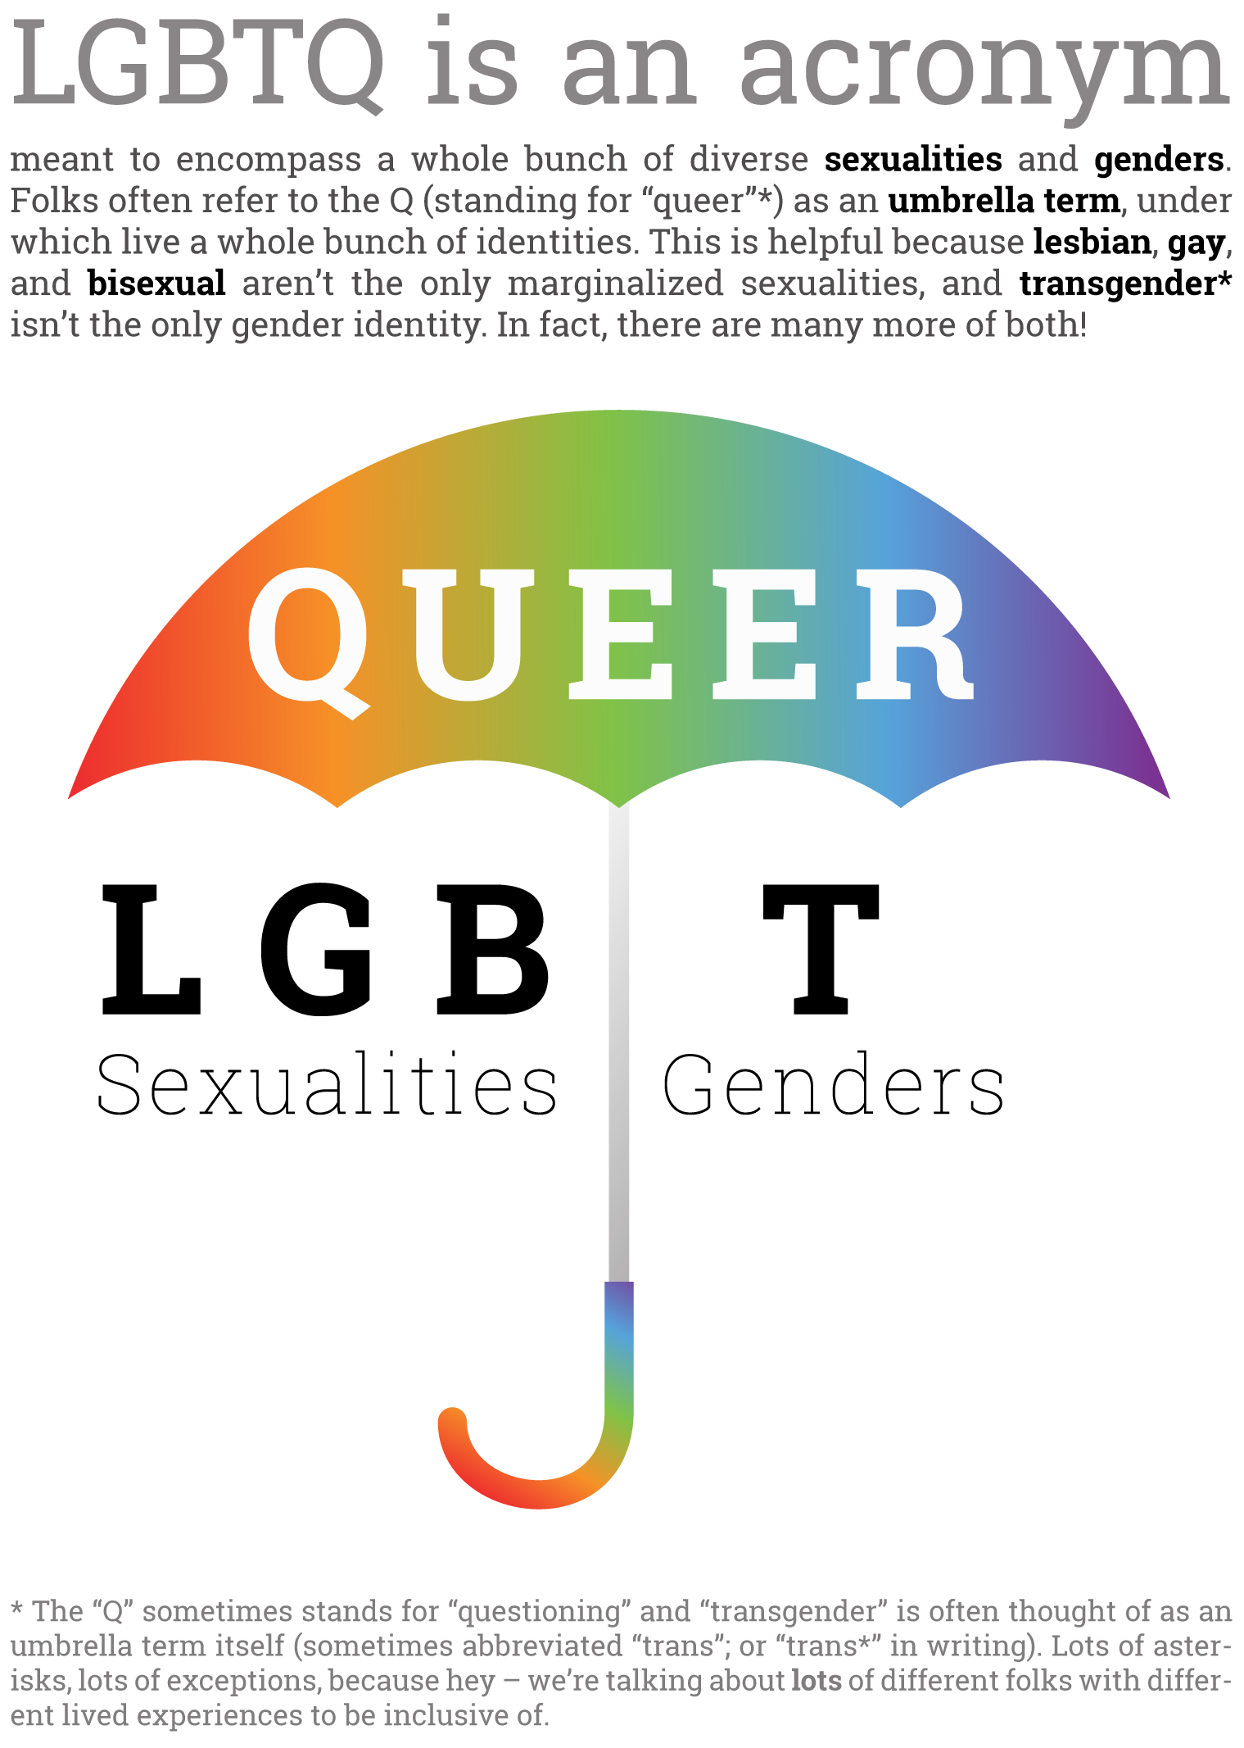

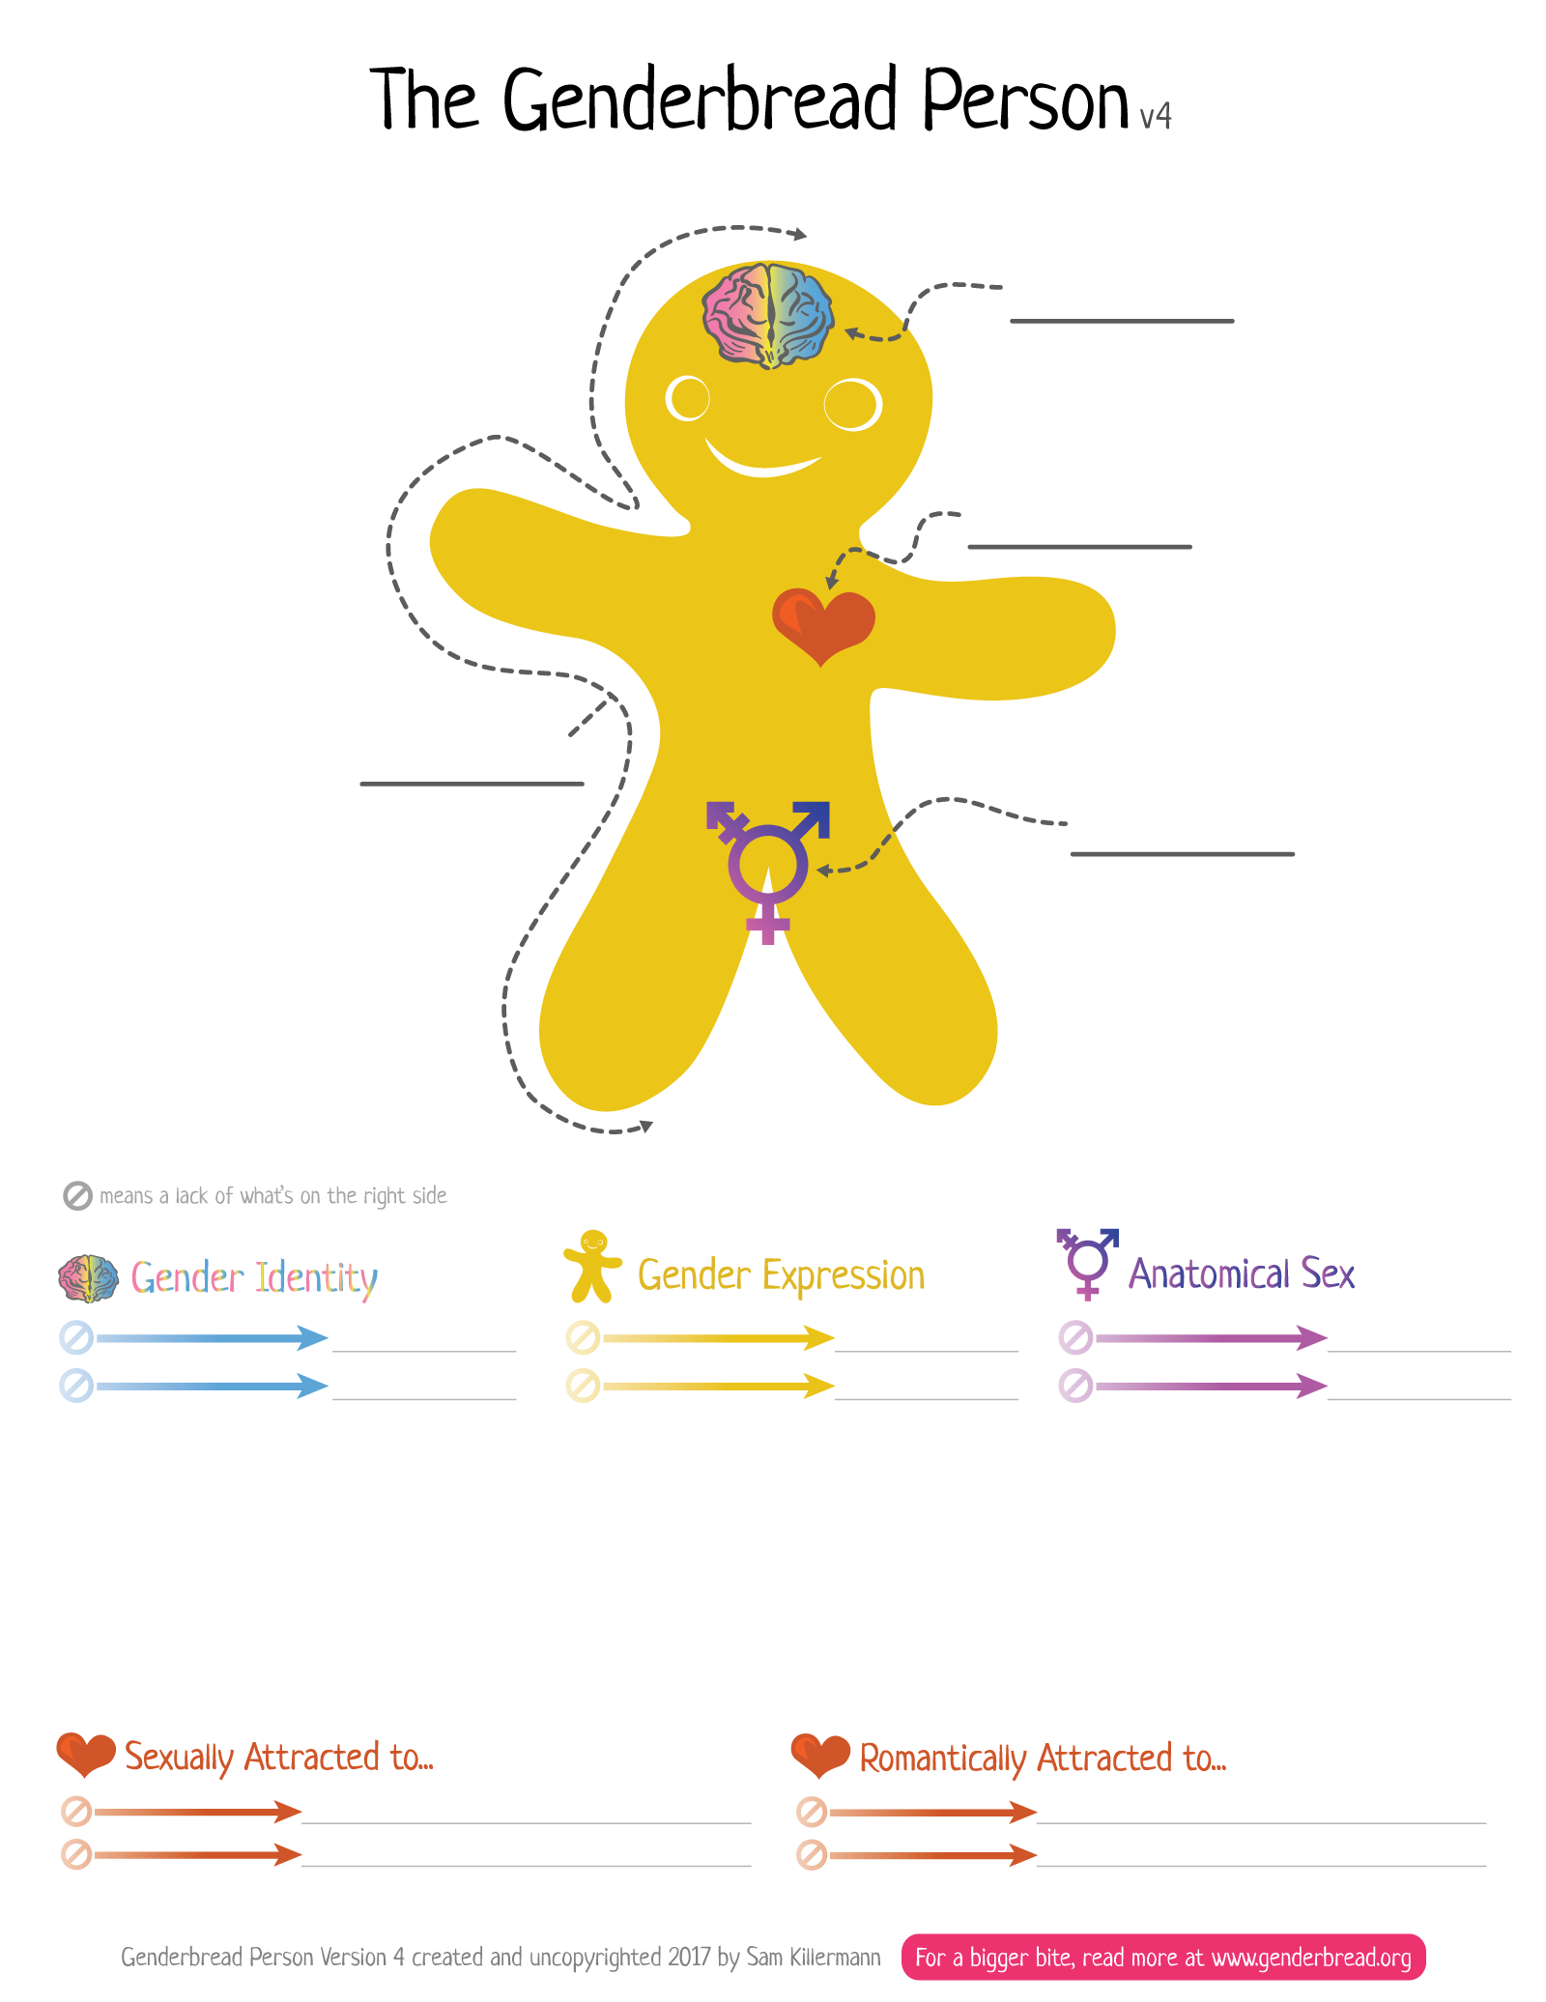

Privileges for Sale
Please look at the following list of privileges. Each privilege costs $100 to purchase. As a group, please purchase as many privileges as your money allows.
- Celebrating your marriage(s) with your family, friends, and coworkers.
- Paid leave from your job when grieving the death of your partner(s).
- Inheriting from your partner(s)/lover(s)/companion(s) automatically after their death.
- Having multiple positive TV role models.
- Sharing health insurance with your partner(s).
- Being able to find role models of the same sexual orientation.
- Being able to see your partner(s) immediately if in an accident or emergency.
- Being able to be promoted in your job without your sexuality playing a factor.
- Adopting your children.
- Filing joint tax returns.
- Able to obtain child custody.
- Being able to complete forms and paperwork with the information you feel most accurately communicates who you are.
- Being able to feel safe in your interactions with police officers.
- Being able to travel, or show ID in restaurants or bars, without fear you’ll be rejected.
- Kissing/hugging/being affectionate in public without threat or punishment.
- Being able to discuss and have access to multiple family planning options.
- Not questioning normalcy both sexually and culturally.
- Reading books or seeing movies about a relationship you wish you could have.
- Receiving discounted homeowner insurance rates with your recognized partner(s).
- Raising children without worrying about state intervention.
- Having others comfort and support you when a relationship ends.
- Being a foster parent.
- Using public restrooms without fear of threat or punishment.
- Being employed as a preschool or elementary school teacher without people assuming you will “corrupt” the children.
- Dating the person you desired in your teens.
- Raising children without worrying about people rejecting your children because of your sexuality.
- Living openly with your partner(s).
- Receiving validation from your religious community.
- Being accepted by your neighbors, colleagues, and new friends.
- Being able to go to a doctor and getting treatment that doesn’t conflict with your identity.
- Being able to access social services without fear of discrimination, or being turned away.
- Sponsoring your partner(s) for citizenship.
- Being open and having your partner(s) accepted by your family.
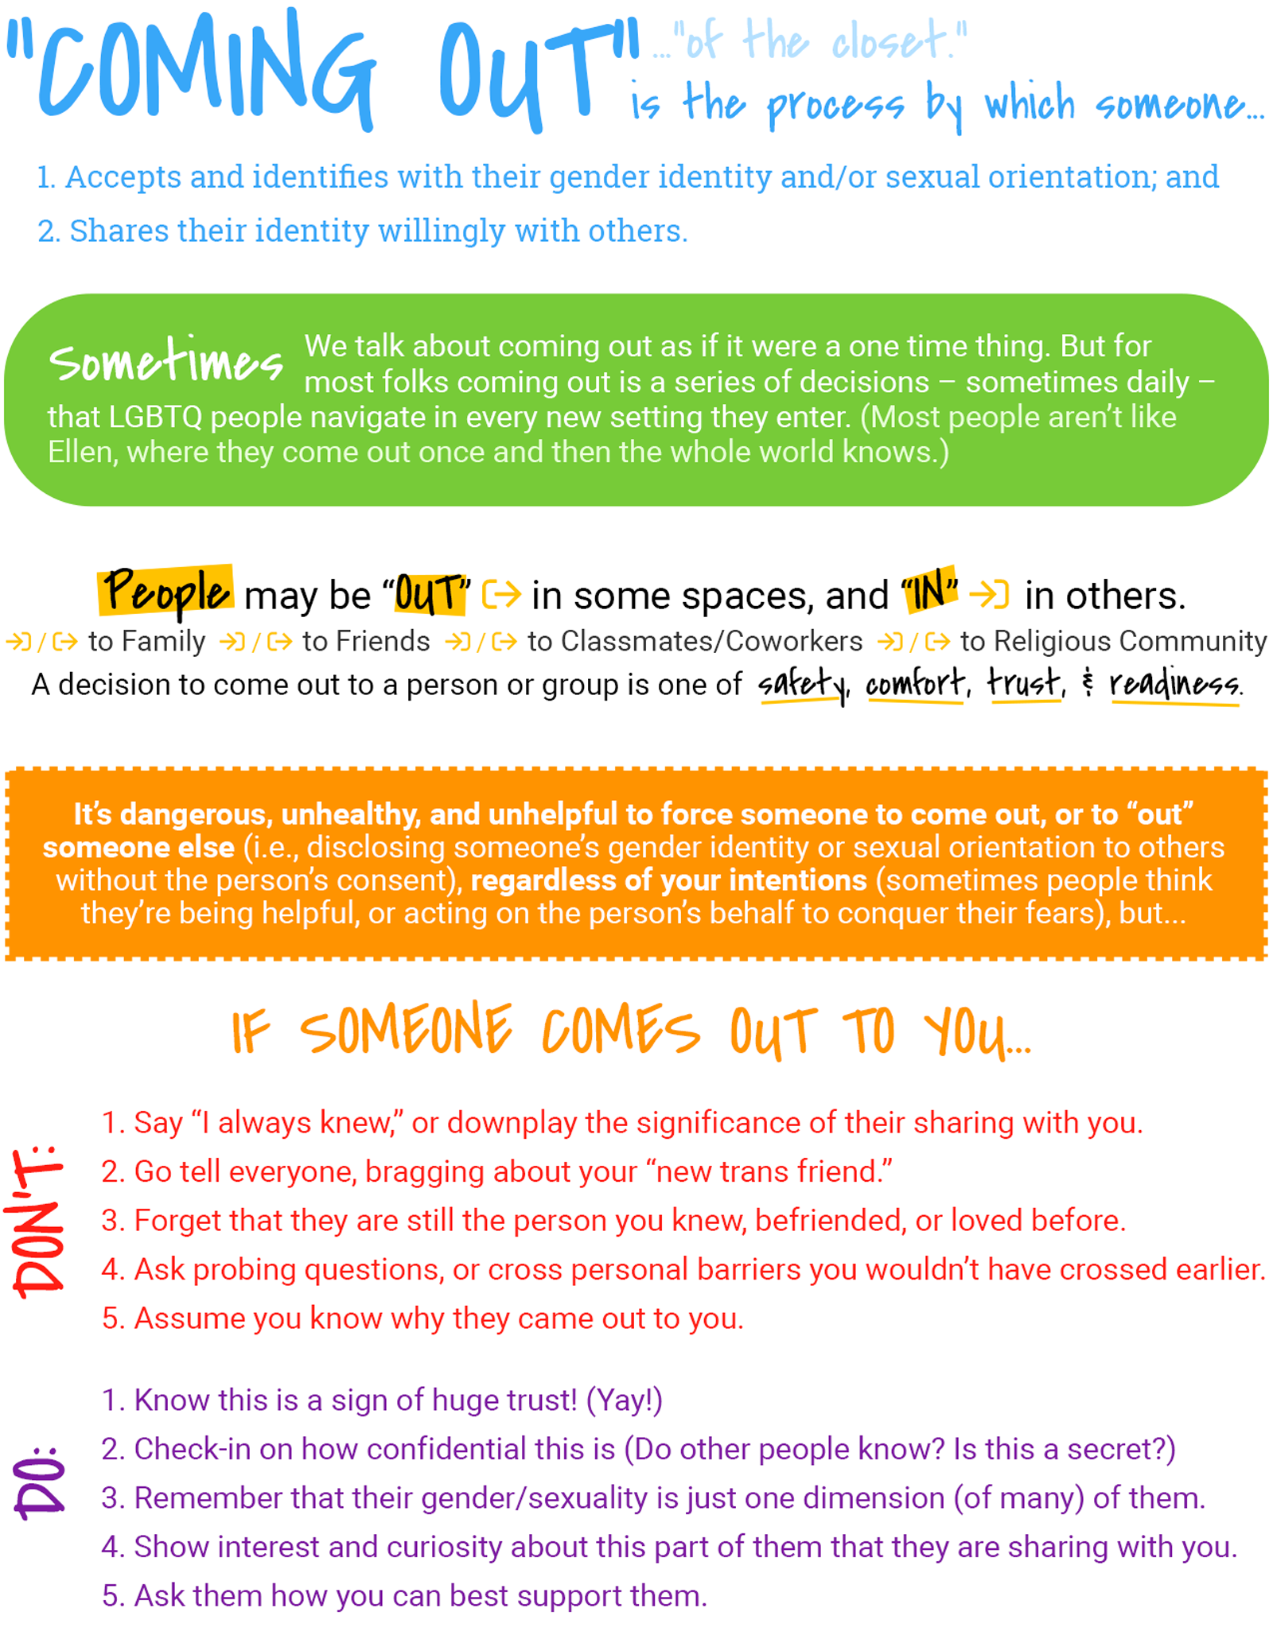
Participant Feedback Form
Please answer honestly :)
What is one thing that you learned from the training today? What did you enjoy about today’s training?
____________________________________________________________________________________________________________________________________________________________________________________________________________________________________________________________________________________________________________________________________________________________________________________________________________________________________________________________

What could be improved for the next time this training is facilitated? How do you think this training could be improved?
____________________________________________________________________________________________________________________________________________________________________________________________________________________________________________________________________________________________________________________________________________________________________________________________________________________________________________________________

Who would you recommend this training to? What would you say to get them interested?
____________________________________________________________________________________________________________________________________________________________________________________________________________________________________________________________________________________________________________________________________________________________________________________________________________________________________________________________

Additional feedback for the facilitators? This could be in regards to material covered or the facilitation process.
____________________________________________________________________________________________________________________________________________________________________________________________________________________________________________________________________________________________________________________________________________________________________________________________________________________________________________________________

Resources
Websites, reading lists, recommended orgs, and more at szp.guide/resources

Full List of Vocab Terms: szp.guide/vocab

Websites for Learning More
- Asexual Visibility and Education Network — www.asexuality.org
- Bisexual.org — www.bisexual.org
- Everyday Feminism — www.everydayfeminism.com
- Get Real — www.getrealeducation.org
- It's Pronounced Metrosexual — www.itspronouncedmetrosexual.com
- Salacious — https://salaciousmagazine.com
- Soul Force – www.soulforce.org
- TransWhat? — www.transwhat.org
- We Are The Youth — www.wearetheyouth.org

Organizations Doing Good
- GLAAD — www.glaad.org — Gay & Lesbian Alliance Against Defamation
- GLSEN — www.glsen.org — Gay, Lesbian, and Straight Education Network
- Family Acceptance Project — https://familyproject.sfsu.edu/
- It Gets Better Project — www.itgetsbetter.org
- National Gay and Lesbian Task Force — www.thetaskforce.org
- The “Not All Like That” (NALT) Project — http://notalllikethat.org
- The Religious Institute — http://www.religiousinstitute.org
- PFLAG — www.pflag.org — "Parents, Families, Friends, and Allies United with LGBT People"
- Transgender Law Center — www.transgenderlawcenter.org
- The Trevor Project — www.thetrevorproject.org

Want even more Resources?
We have even more resources that don’t fit on this page. Head to www.thesafezoneproject.com/resources to find more!

Are you, or is someone you know, in crisis?
Trevor Hotline: “If you’re thinking about suicide, you deserve immediate help.”
Call 1-866-488-7386 or text “TREVOR” to 1-202-304-1200
Trans Lifeline: “A peer support service run by trans people, for trans and questioning callers.”
Call 877-565-8860 (United States) or 877-330-6366 (Canada)

